DO’s, DONT’s, and FAQ’s

- DO’s
  - Contact Bushnell Golf
    - Primary Contact: Your store’s Bushnell Golf Sales Rep
    - Secondary Contact: Bushnell Dealer Customer Service (1-800-221-9035)
  - If the laser will not turn on, confirm that it doesn’t need a new battery. (Bushnell Golf recommends Energizer or Duracell)
  - If the claim is the unit is not providing accurate distances, confirm the unit is in yards & not in meters.
  - If GPS Watch is “locked up” hold all four corner buttons until the screen powers off to reboot the watch.
  - If GPS Watch will not charge, wipe charging contacts clean with an ammonia-based glass cleaner such as Windex.

- DONT’s
  - Take back/Request an RA for an out of date unit (Tour V2, Tour V3, or Tour Z6 rangefinders or Neo-XS and Neo iON watches, Hybrids, V4’s)
  - Take back/Request an RA for a unit with visible damage (cracked housing for example)
  - Take back/Request an RA for a non-waterproof unit (any model except Pro XE) that has water damage

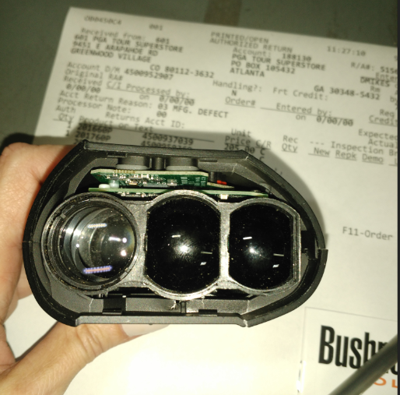
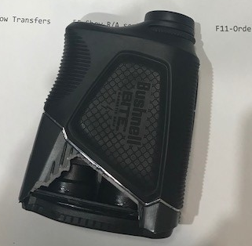
DONT
DONT

